TITLE (Times New Roman, 14 Pt., Bold, Uppercase, Centered)
Name SURNAME^{1*}, Name SURNAME² (11 Pt., Bold, Centered)

¹ Department Name, Faculty/School, University Name, City, Country
ORCID: 0000-XXXX-XXXX-XXXX
² Department Name, Faculty/School, University Name, City, Country
ORCID: 0000-YYYY-YYYY-YYYY

*E-mail: yyyy@yyyy.edu.tr

ABSTRACT (12 Pt., Bold, Left-Aligned)

This section should include the purpose and scope of the study, the methodology used, the main findings, and the conclusions reached. The abstract should be written as a single paragraph, justified, without paragraph indentation. Citations and references to figures and tables should not be included in the text (unless absolutely necessary). The abstract should be between 150 and 300 words. The font should be Times New Roman, with 1.0 line spacing and a font size of 10 points.
Keywords: Keyword 1, Keyword 2, Keyword 3 (3-5 keywords, capitalized, separated by commas).

1. INTRODUCTION (12 Pt., Bold, Capital Letters, Left-Aligned)

This section describes the information required to prepare the papers accepted for the 14th International Symposium of Vocational Schools. Please read these rules carefully to finalize your paper. After finalizing your paper according to the rules described here, submit it.
The introduction should clearly state the subject, importance, place in literature, and purpose of the study. For full-text submissions, the page layout is standardized to 2.5 cm (1 inch) for the top, bottom, right, and left margins. The main text font size should be 11 points, and the line spacing should be 1.15. In-text citations should adhere to academic standards (e.g., APA format). Example citations: For single-authored studies (Yılmaz, 2023), for two-authored studies (Demir and Kaya, 2024), and for studies with three or more authors (Aksoy et al., 2025), abbreviations should be used.

2. MATERIAL AND METHODS (12 Pt., Bold, Capital Letters, Left-Aligned)

This section should clearly and comprehensively describe the materials used in the research, experimental setups, data collection tools, and analytical methods or statistical approaches applied. The aim is to enable another researcher to replicate the study using the same methodology.

2.1. Subtitle (11 pt., Bold, First Letter Capitalized)

Second or third-level subheadings may be used to elaborate on the study when necessary. Subheadings should also be numbered in accordance with the main sections.

$E=mc^{2}$ (1)

Mathematical formulas or technical equations within the text should be centered, as shown in the example above, and numbered sequentially in parentheses, aligned to the right.

3. RESULTS AND DISCUSSION (12 Pt., Bold, Capital Letters)

The data obtained, analysis results, graphs, and tables are presented in this section. The findings should not only be listed but also discussed in depth, comparing them with other studies in literature to highlight similarities and differences.

Table 1: Font and Point Size Properties (10 Pt., Centered)
Subject | Punto | Font Feature
Paper Title | 14 | Bold
Author Information | 11 | Normal
In-text Text | 11 | Normal
First Level Heading | 12 | Upper case, Bold
Subheadings | 11 | Lowercase (first letter capitalized), Bold
Table and Figure Names | 10 | Normal
Table Data and Sources | 9-11 | Normal
References | 10 | Normal

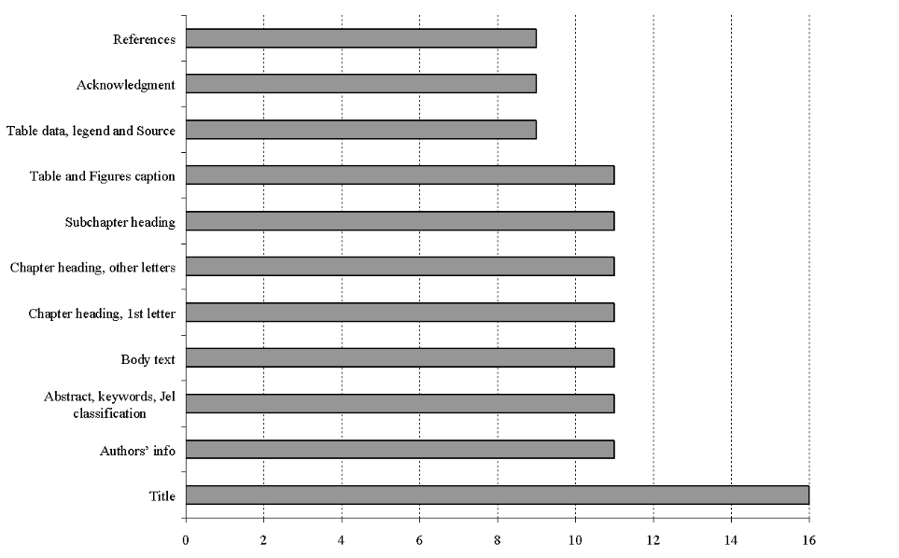
Figure 1: Example Figure Title (10 Pt., Centered)

Table titles should be placed at the top of the table, and figure or graph titles should be placed below the respective image. All titles should be 10-point font and centered.

4. CONCLUSION (12 Pt., Bold, Capital Letters)
The key outputs and clear findings of the study should be presented in this section in bullet points or as a summarizing paragraph. Additionally, the contributions of the results to sectoral/vocational education and concrete suggestions for future academic research should also be shared under this heading.

ACKNOWLEDGEMENTS (12 Pt., Bold) (Optional)

This study was supported by the [Institution/University Name] Scientific Research Projects Coordination Office under project number [Project-Number].

REFERENCES (12 Pt., Bold, Capital Letters)

((References should be listed alphabetically, in 10-point font, single-spaced, and in hanging paragraph format.)
Aksoy, T., & Can, S. (2025). The Effect of Aerodynamic Improvements on Fuel Consumption. 13th International Vocational Schools Symposium (UMYOS), Proceedings, 45-52.
Kaya, Ö. (2024). New Trends in Engine Technology (2nd Edition). Academic Publishing.
Yılmaz, A., & Demir, M. (2023). Improving the Quality of Education in Vocational Schools. Industrial Education Journal, 15(2), 123-135.

